High Productivity of Membrane-Based Protein-A Affinity Chromatography for Monoclonal Antibody and non-Antibody Purification
Kareem Fakhfakhª, Adam Powell^{b}, Faisal Uddin^{b}, Martyn Hulley^{b}
E-mail address: Kareem.fakhfakh@astrazeneca.com (Kareem Fakhfakh)
ªBioprocess Technologies and Engineering, Biopharmaceutical Development, R&D, AstraZeneca, Gaithersburg, US
^{b}Purification Process Sciences, Biopharmaceutical Development, R&D, AstraZeneca, Cambridge, UK
Key Words: Membrane affinity chromatography, Protein A, Intensified bioprocessing, Low titer

Abstract
Here we share a practical evaluation of a novel membrane-based affinity chromatography unit monitoring recovery, monomer purity, impurity clearance (host cell protein - HCP, DNA), and residual Protein-A ligand for several monoclonal antibody (mAb) and non-mAb species over the lifetime of the membrane at laboratory and pilot scales. Initial evaluation was performed on a 9 mL Gore® Protein Capture Device with recommended CIP; minimal recovery loss is observed over 100 cycles. Membrane capacity ranged from ~25 – 35 mg/mL (n=5 products). Increased volumetric flow results in higher productivity (g/L/h) than MabSelectTMSureTM affinity packed bed resin. We evaluated a 58 mL Gore® device showing stable monomer purity, HCP and DNA clearance over 50 cycles even with an aggressive deviation from the recommended CIP protocol (15min with 0.5 N NaOH versus 3min with 0.2 N NaOH between products) – though modest losses in recovery were observed. A Design of Experiment evaluated dynamic binding capacity (DBC) and productivity as a function of titer (0.2 – 2 mg/mL) and residence time (20 -120s) which showed DBC10%*0.8 ranging from 32 – 44 mg/mL (n=1 product). Though capacity was relatively insensitive to titers tested and despite increased capacity with slowed loading, productivity was highest at fast loading and highest titer. These data support the use of membrane-based affinity chromatography for high productivity transient culture produced mAbs and their Fc-containing derivatives. We anticipate data reported herein will bolster wider adoption of high-productivity technologies that hasten product purification at bench and pilot scale, leading to more therapeutic candidates.

1.0 Introduction

The emergence of next generation mAb biologics with enhanced functionality and efficacy has driven new healthcare opportunities. For example, in cancer immunotherapy, bi-specific antibodies with two distinct heavy and light chains can bind to both an immune cell and a tumor target cell to facilitate an artificial immune response¹. Likewise, strategies fusing an antibody fragment crystallizable (Fc) domain to an active proteins or peptide to enhance its half-life have been successful in the clinic relating to multiple therapy areas including immune control². Such strategies have contributed to a burgeoning of new Fc-containing therapeutics targeting new combinations of targets and with further modifications to enhance their specificity³.
With a broadening portfolio of targeted treatments for ever smaller segments of responding patients, personalized medicine drives production trends toward smaller more numerous batches. Transient cultures, often of low titer (<1 g/L) and increasingly higher volume, enable shorter development times for new molecules before lengthy establishment of stable production cell lines and culture optimization is undertaken⁴. Though the application of this work is for pre-clinical development scales, at pilot or production scale, perfusion bioreactors of integrated continuous manufacturing campaigns often have several days where large volumes of low titer material is produced^{5,6}. To accommodate intensified purification of additional pre-clinical batches with ever higher volumes of low-titer material, these applications may benefit from evaluation (i.e. recovery, purity, process intensity, buffer consumption) of new high productivity purification technologies.
Protein A based affinity chromatography is a mainstay for bulk purification of antibodies and Fc-containing therapeutics generated in CHO cultures after primary clarification³. Compared to optimized clones that regularly achieve 5-10 g/L titers, a low titer – high volume transient culture feed stock has longer chromatography load times with commensurately lower purification productivity (defined as protein purified per unit time and column volume; e.g. g/L/h) and increased risk of bioburden contamination. While packed-bed chromatography is the current first choice for production, its high cost⁷, need for packing validation and sanitization, and limited processing flow rates motivate advancements in alternative technologies⁸.
Highly porous membrane-based supports coupled with catalogues of various ligands serve as a promising alternative for product capture. Compared to internal surface areas of porous beads where diffusion is limiting, convection dominates mass transport as products pass through functionalized support structures (e.g. macropores and/or channels), enabling increased loading flowrates with lower residence times and pressure drop⁸. Further, single-use equipment with consistent support structures can eliminate packing validation compared to packed beds and reduce scale up concerns from scale-dependent flow dynamics⁹.
Several chromatography membranes have been commercialized for various chromatographic applications (IEX, HIC, affinity, etc.) and with increasing attention focused on pre-validated, single-use units to streamline downstream production^{8,9}. For example, Pall Mustang Q anion exchange has been employed for endotoxin clearance of protein streams¹⁰, and for higher throughput plasmid DNA purification¹¹ among others¹². Of convective mAb affinity materials, electrospun nanofiber adsorbents (e.g. Cytiva Fibro™ PrismA¹³) and macroporous membrane based adsorbents (e.g. Sartorius Sartobind® Protein A¹⁴ or Rapid A¹⁵) are commercially available. While manufacturer performance data are available, a dearth of performance data limits technology adoption.
This study provides a breadth and depth to the performance of a novel Gore® protein A affinity chromatography membrane for a library of current and next-generation protein therapeutics. Purity, recovery, dynamic binding capacity, impurity clearance for products including mAb, Fc-fusion, and bispecific mAb are reported over 50 or 100 cycles alongside a discussion of sanitization and productivity. Taken together, these data support the use of membrane-based affinity chromatography for high productivity transient culture produced mAbs and their Fc-containing derivatives.

2.0 Materials and Methods

2.1 Materials

2.1.1 CHO-derived products
Five CHO culture produced Fc-containing protein therapeutics, were studied including four monoclonal antibodies (mAb 1, 2, 3, and 4), one bispecific paired half-antibody (Bs-1), and one Fc-fusion (Fc-1). Product titers were quantified by Protein A affinity-based high performance liquid chromatography (HPLC) were 6.3, 5.3, 5.9, 3.1, 2.5 mg/mL for mAb1, mAb 2, mAb 3, Bs-1, and Fc-1 respectively. Product isoelectric points, MW, and initial host cell protein (HCP) and host cell DNA residual content (ng/mg) are tabulated in supplementary Table S1. All product sources were conditioned media, stored as centrate filtered by at least one 0.22 µm filter except mAb 4 which was pre-purified by MabSelect™SuRe™ (Cytiva, Marlborough, MA, USA) titrated to pH 7.4, and 0.22 µm filtered before use.

2.1.2 Chromatography Equipment
Gore® Protein Capture Device with protein A membranes of three scales, 1.0 mL, 9.0 mL and 58.0 mL were studied (PROA101, PROA 103 and PROA201 respectively; Newark, DE, USA). MabSelect™SuRe™ resin (17543801, Cytiva) was also used. A fraction collector equipped AKTA Pure was used for 1.0 mL and 9.0 mL membranes while an AKTA Pilot600S (Cytiva) was used for 58 mL membrane testing.

2.2 Dynamic Binding Capacity (DBC) Studies

2.2.1 Traditional Methods
Either purified material, or mAb in conditioned media (CM) was fractionated during membrane loading and quantified by either A₂₈₀ (Trinean Lunatic, Unchained labs, CA) or an HPLC (Agilent 1260 Infinity, Santa Clara CA) equipped with a 0.1 mL POROSTM A affinity column (Thermo Fisher Waltham, MA) respectively. The volume and mass loading corresponding to 0.74-0.9 × DBC10% (i.e. 74% to 90% of DBC10%, 10% of full breakthrough) was set to the dynamic binding capacity. For a packed bed method used in Figure 1, the column was equilibrated with 50 mM tris, pH 7.4 before loading conditioned media at 300 cm/h on a Tricorn 5/20 (4 mL, 20 cm bed height; Cytiva).

2.2.2 FlowVPE – in-line method
A fraction collector equipped AKTA Pure (Cytiva) was run with both its internal UV flow cell and in-line with an upstream variable-pathlength UV flow-cell FlowVPE (Repligen, Waltham, MA) set to 280nm absorbance. A 9 mL Gore® unit (PROA103) was used for DBC experiments adapted to flow conditions in Table 1 and scaled to 58 mL for mAb1, mAb 2, Bs-1, and Fc-1.
UV absorbance breakthrough curves from both UV detectors were aligned to establish a common volume axis. The broader UV range of the Flow-VPE enabled detection of two sequential breakthrough transitions; i) for impurities alone as mAb binds to the column, and ii) corresponding to the additional breakthrough of mAb. The DBC was then computed between transitions, setting the A₂₈₀ value of the first plateau as a baseline and the second plateau as a maximum. Loading target capacities were computed as 0.9 × DBC10%, the capacity (mg mAb per mL membrane) at which 10% breakthrough occurred.

2.2.3 Pure mAb Loading Method for Productivity Assessment
For productivity studies, mAb 4, purified using MabSelect™SuRe™ and titrated to pH 7.4 with 0.5 M Tris base (J.T. Baker, Phillipsburg, NJ) before dilution to either 0.2 mg/mL, 1.0 mg/mL or 2.0 mg/mL with 50 mM Tris pH 7.4. Each feed was loaded onto an AKTA Pure (Cytiva) FPLC instrument equipped with a 1 mL (ProA101 Gore®) membrane capture device operated according to Table 1 excluding the Long CIP step – since only one product was being studied – at a loading residence time of 20 s, 60 s or 120 s for a total of nine runs. All runs were loaded above 75 mg mAb mL⁻¹ membrane with one run at each titer loaded beyond 100 mg mAb/mL membrane to full breakthrough where its absorbance was recorded. DBC10% values were calculated from UV280 traces exported from AKTA UNICORN 7.4 software (Cytiva), computed in MATLAB R2020a (MathWorks, Natick MA, USA), and imported into JMP17 (JMP, Cary NC, USA) for contour plot generation and analysis. Productivity values were computed assuming the manufacturer’s 0.8× safety factor, the buffer optimized method in Table S3, and a conservative 90% recovery.

2.3 Life Cycle Studies
Following DBC determination on the 9 mL membrane, a 58 mL membrane was installed on an AKTA Pilot 600 (Cytiva) for scale up life cycle studies. All buffers and products were 0.22 µm filtered before use. Membranes were loaded as described in Table 1 up to a binding capacity of 33.0, 30.0, 30.0, 35.0 and 25.0 mg/mL for mAb 1, mAb 2, mAb 3, Bs-1, and Fc-1 respectively.
Chromatography cycles were grouped to balance material availability and query the membrane lifespan and described in their respective sections. Each cycle was run according to the phases in Table 1. The column was rigorously sanitized (long CIP) between molecules consisting of a long 15min, 0.5 N NaOH CIP after 3.6 membrane volumes (MV) of flow. Within the cycle, a short CIP occurred before membrane regeneration consisting of 0.1 N NaOH.
Table 1. Chromatography Method for Gore® Protein Capture Device
Phase | Membrane Volumes (MVs) | Residence time (s) per MV | Flow rate (mL/min) | Buffer
Equilibration | 5 | 20 | 174 | 50 mM tris pH 7.4
Load volume | Capacity Dependent | 30 | 116 | -
Re-Equilibration 1 | 6 | 30 | 116 | 50 mM tris pH 7.4
Wash | 6 | 20 | 174 | 50 mM tris, 0.5 M NaCl, pH 7.4
Re-Equilibration 2 | 6 | 20 | 174 | 50 mM tris pH 7.4
Elute | 5 | 20 | 174 | 25 mM NaAc pH 3.6
Acid Strip | 4 | 30 | 116 | 100 mM acetic Acid
Re-Equilibration 3 | 4 | 20 | 174 | 50 mM tris pH 7.4
Short CIP | 3.6 | 50 | 69.6 | 0.1 N NaOH
Regeneration 4 | 8 | 20 | 174 | 50 mM tris pH 7.4
Long CIP (if applicable) | 3.6 (+ 15min hold) | 54 | 64.4 | 0.5 N NaOH

Recovery, purity, log value reduction (LRV) of both residual HCPs and DNA, and residual leached protein A (ProA) were computed for each cycle the four products in a cluster, and for pools of 5-6 cycles between clusters.
To understand the life cycle performance of the 58 mL membrane with limited materials, multiple products were applied to a single membrane. To avoid biasing higher performance for the products applied earliest in the life of the membrane, one reference cycle for each product (four in total) at three milestones in the lifecycle of the membrane: at the beginning (ca. cycle 1), middle (ca. cycle 25), and end (ca. cycle 50) of the study. Between these milestones, the remaining cycles were carried out with the most abundant products as listed in the supplementary Table S2. The first reference set of cycles serves as a baseline performance for a ‘fresh’ column. 54 cycles was selected as a lifecycle endpoint due to material constraints slightly exceeding our traditional usage of laboratory and pilot scale packed bed affinity resin.
An extended lifecycle was studied on a 9 mL Gore® unit with a third mAb where operating conditions were more closely aligned to manufacturer’s recommendations compared to the method in Table 1 . Key differences were the absence of re-equilibration 1 and modification of the sanitization step towards gentler CIP conditions. Specifically, for the short CIP, the membrane was stripped with 0.2 N NaOH at 1.2 MV/min for 3 minutes contact time before sanitization with 0.1 N NaOH at 1 MV/min for 15-minute contact time every 20 cycles and the long CIP was omitted.
Purified samples were quantified by UV spectroscopy at 280nm on a Trinean Lunatic and compared with load values to compute recovery. Purity was determined by high performance size exclusion chromatography (HP-SEC) on a TskGel3000SWXL (Tosoh Bioscience) equipped Agilent 1260 HPLC system (Agilent Santa Clara, CA).
Both residual CHO HCP and leached protein A ligand were quantified using in-house developed sandwich ELISA assays while residual genomic DNA extracted from in-process samples was quantified by qPCR having primers directed against CHO genomic repeats (see supplementary).

3.0 Results and Discussion

3.1 Dynamic Binding Capacity (DBC)
Filtered CHO centrate containing mAb was used for DBC computation using both a fractionated load and in-line method as applied to a 4 mL column volume packed bed (MabSelectTMSureTM ) column. DBC at 10% breakthrough (DBC10%) appears equivalent for the two methods, UV (A₂₈₀) and ProA-HPLC (Figure 1) and was deemed suitable for DBC10% computation using the dynamic method only.
The FlowVPE in-line method was used to collect DBC10% values, computed as the intersection of the baseline corrected C/C₀ and the 10% breakthrough using only the Gore® Protein Capture Device with Protein A. For a 30 s residence time, DBC10% values were 36.5, 33.0, 38.9, and 33.9 mg/mL for mAb 1, mAb 2, Bs-1, and Fc-1 respectively (see supplemental). For mAb 3, a traditional method was used having a DBC10% of 33.0 mg/mL.
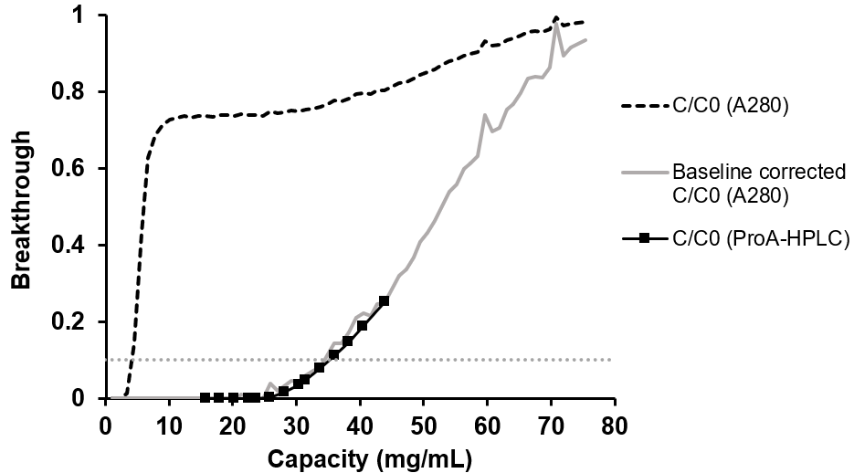
Figure 1. An overlay of concentration normalized breakthrough curves for mAb1 on a packed bed column shows overlap for both the baseline corrected UV A₂₈₀ (solid grey) chromatogram trace and ProA HPLC based breakthrough data (black squares) and a substantially equal DBC10% (intersection with grey dotted line) values. A baseline for normalization was defined at the first plateau of the dual break through UV curve (black dashed line).
For a polyclonal human IgG1 loaded at 5 mg/mL, membrane capacity at 30 s residence time for the Gore® membrane was between ca. 30-40 mg/mL, comparable to this work and increased above 60 mg/mL at 120 s residence time¹⁶ in line with manufacturer data^{17,18}. Other membranes where convective transport is dominant (e.g. HiTrap Fibro™ PrismA and Purilogics Purexa™ PrA) saw consistently high membrane capacity (ca. 60-70 mg/mL) from 5-120 s residence times^{16,19}. While previous generation membranes (e.g. Sartobind Protein A; 80 s residence time) and monoliths had dynamic binding capacities around 5-10 mg/mL ^{14,20,21}, DBC10% values of 34.4 to 50.1 mg/mL have been reported for the newer generation Sartobind Rapid A between 12 and 120 s residence time and can improve upon packed bed type resins¹⁵.
Product titers studied in this work ranged between 2.5 and 6.3 mg/mL for mostly IgG1 products. Fc-1 saw a slightly lower capacity, consistent with previous relative results compared to mAb1 on a packed bed MSS column (4 minute residence time; data not shown). For the Gore® Protein capture device, increasing titer from 2 to 5 mg/mL improved DBC10% less at 12 s compared to that increase at 120 s residence time supporting diffusion related transport enhancements though all 12 s residence time DBC10% data are expectedly lower¹⁶. Assuming a linear relationship for this trend, for a lower titer, 0.5 mg/mL capacity values converge to ca. 21-22 mg/mL for independent of residence times between 12 s and 120 s though the membrane has been updated as communicated in a February 2023 Notification of Change and improved pressure drop vs. flow rate data published in revisions to the Product Data Sheets^{22,23}.
Gore® protein-A capture membranes comprise a combination of large and small pore structures in the composite fluoropolymer (e.g. PTFE) – inorganic porous particle matrix to which the protein-A ligand is covalently bonded, supporting both convective and diffusive mass transfer²⁴. Compared to other membranes, the composite silica-PTFE-based Gore® membrane had a higher specific surface area and high permeability compared to other high performing cellulose-based membranes and shows a residence time-dependent loading capacity¹⁶. Nominally, the Gore® membrane has 100 nm pore diameter, porous single membrane thickness of 650 µm¹⁸ with a permeability of 5.14 × 10⁻¹⁵ m² which are stacked to a measured height of 0.35 cm¹⁶, though the membrane has since been updated to a more permeable version to improve pressure drop. As such, the membrane information cited may no longer be relevant due to the recent Gore® membrane change (Jeffrey Cassel, Technical Leader, Chromatography Products at W. L. Gore, e-mail communication, February 4th, 2024).

3.2 58 mL Gore® Membrane Performance
We investigated the performance of a 58 mL Gore® Protein Capture Device for pilot scale production over greater than 50 cycles, for a panel of four products encompassing traditional mAb formats (mAb 1 & 2), a bi-specific antibody (Bs-1) and an Fc-fusion modality (Fc-1).
Purity and impurity clearance of HCP and DNA from CHO was measured throughout and plotted in Figure 2 with feed HCP and DNA content in supplementary Table S1. Though initial product purity and impurity clearance differed between products, throughout the ~50 cycle study membrane performance deviated little from the first cycle. Monomer purity and aggregate content was essentially unchanged for all products though Bs-1 saw marginal increases in aggregation. Similarly, and for over 200 cycles, a HiTrap and HiScreen Fibro PrismA (Cytiva) showed consistent HCP clearance and yield²⁵.
HCP clearance was high overall, ≥ 2.0 LRV, and changing negligibly over 50 cycles. Initial HCP content ranged from 217,746 to 654,374 ng HCP/mg product (Table S1) and was not related to HCP clearance: R²= 0.139 and R²= 0.069 for HCP clearance (LRV) vs initial HCP content in units of ng/mg product and ng/mL solution respectively. Similarly, DNA LRV for all products was stable, and increasing only for mAb 2 at 25 cycles though unfortunately with its endpoint measurement returned no result upon analysis. Generally, weak or no correlation was observed between impurity clearance, based on each product’s first cycle, and feed impurity content for DNA (R²= 0.43) and HCP (R²= 0.14) respectively. HCP and DNA LRV values were higher than values reported elsewhere for the Gore® Capture Device and 3 other membrane adsorbers¹⁶ though impurity loads for HCP and DNA were either comparable or more than an order of magnitude lower respectively where different HCP ELISA kits were used for quantification¹⁶ and DNA methods varied (either fluorescence or q-PCR based) which may have contributed to discrepancies. Additionally, the higher impurity clearance seen in our study may have resulted from the inclusion of a high salt wash step to remove non-specifically bound HCPs and DNAs; this step was not used in other work¹⁶. The wash potentially compensated for the longer residence time and lower safety factor used in our study compared to previous studies.
Comparing the performance to a platform affinity process for mAb1 using a MabSelect™SuRe™ (previously used and sanitized), HCP clearance for the first cycle for the Gore® membrane was slightly lower (LRV MSS=2.4-3.0; n=3), DNA clearance was consistent (LRV MSS =2.6-3.7; n=3 runs), and percent recovery was slightly, ca. 5%, higher (MSS = 94.6 – 96.6 %, n=3 runs); data not shown. When Sartobind Rapid A purification was compared with MabSelect™Sure™, recovery (94.7-96.4 %) and HCP reduction (LRV ca. 2) were comparable while host cell DNA removal was slightly higher (LRV ca. 2-3) for the membrane for an IgG1 tested (pI =8.4, 145.4 kDa)¹⁵.
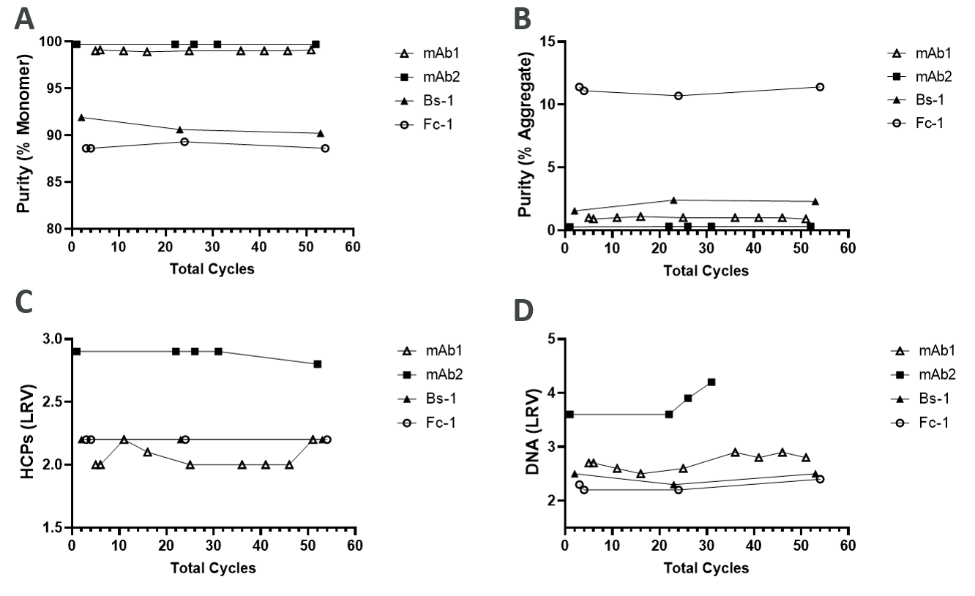
Figure 2. Product purity and impurity log value reduction for four Fc containing products, mAb 1, mAb 2, Bs-1, and Fc-1. HPLC-SEC based monomer purity (Panel A) and aggregate (Panel B), along with residuals clearance for HCP (Panel C) and DNA (Panel D) for each of the products. Generally, all clearance and purity data are stable across cycles. Initial HCP and DNA content listed in Table S1.
The life cycle testing occurred under a conservative and rigorous sanitization regime, traditionally applied to packed bed columns²⁶ and since it was not recommended by the membrane manufacturer it can be considered a stress-test for the membrane. The left panel of Figure 3 shows product recovery percentage over 50 cycles for four products. Generally, recovery decreased by ~10-20% for all products except mAb 1 that was relatively unchanged overall, showing some product specific behavior. Since recovery loss appears at least partly molecule specific and doesn’t appear related to size, isotype, or pI differences, or variable heavy chain (V_{H}) germline gene sub-family whose V_{H}3 members may bind outside the Fc region for unmodified protein-A ²⁷ (see Table S1). Though further investigation is needed into V_{H} region or ligand binding thermodynamic and steric differences²⁷⁻²⁹, inspecting chromatogram trends at milestone cycles from Figure 4 (A, B), S3, and S4, mechanisms for losses appear diverse. For example, losses of Bs-1 (Figure 4B) appear due to incomplete elution with losses in the strip over membrane lifetime while losses for Fc-1 (Figure S4) during load and wash appear related to capacity and mAb 2 (Figure S3) appears to have less severe losses in the chase over 50 cycles. DBC10% was not remeasured during the experiment, when measured at 30s residence time, it is expected to be stable over at least 10 cycles ¹⁶ following recommended CIP but for some products, a more conservative safety factor may be required to enhance recovery when using an aggressive CIP.
The right panel of Figure 3 plots the cumulative sanitization time and the cumulative residual protein A recovered from the eluate showing good association between the two curves. Still, the collected residual protein A is an underestimate of the total since only the eluate phase was collected and queried.
Chromatograms for each cluster milestone are shown for mAb 1 and Bs-1 in Figure 4. UV A280 traces overlap for each product except Bs-1, which experiences slight broadened elution and strip 1 losses as cycle number increases. Pressure across the column is low throughout the lifecycle, not exceeding 1 bar (0.1 MPa) despite its fast flow. Pump washes were carried out on all phases except CIP (phase 7) and transitions were accordingly sharp. Though not manufacturer recommended, a buffer chase step, equivalent to 6 MV, was added to ensure UV traces were at baseline before the wash step occurred. Minor recovery loss for mAb 2 and 4 occurred outside the strip phase (see supplementary Figures), likely slight overloading took place. Though for packed bed chromatography, 0.9 × (90% of) the experimentally determined DBC10% is a common capacity target which is what was applied in this work for comparability, Gore® recommends a lower safety factor of 0.8 × DBC10%, instead of 0.9 × DBC10% used here, to avoid yield loss, which likely contributed to overloading and less desirable recovery.
Overall, membrane performance for all products tested saw minimal absolute change over the lifetime of the membrane in terms of impurity clearance product and product aggregation studied (1 ± 5%, 7 ± 7%, and 0 ± 1% for HCP LRV, DNA LRV, and %monomer) even when exposed to the rigorous CIP, traditionally applied to packed bed columns though recovery did decrease on average 19 ± 8%. A 0.2 N NaOH, 3-minute contact time is recommended during cycling and 0.1 N NaOH, 15-minute contact time between use or between molecules. Interestingly, recovery remained high for mAb 1 despite loading beyond the manufacturer’s safety factor and application of a more rigorous sanitization protocol. Future work likely includes bioburden evaluation.

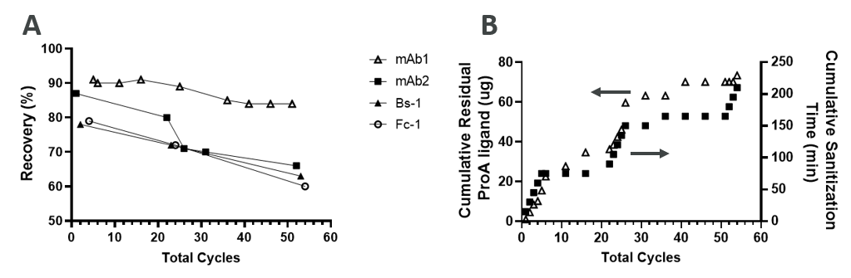
Figure 3. mAb recovery (Panel A) is plotted against total cycle number for various feeds and generally decreases depending on the product. Both cumulative residual protein A ligand mass (Panel B, left axis) and sanitization time (Panel B, right axis) are plotted against total cycles – composed of multiple products run according to table S2 – and increase accordingly. Sanitization conditions were outside manufacturer’s recommendations, both higher in stringency and contact time to be consistent with existing resin based workflows known to generate low-endotoxin eluate. Stringent sanitization was carried out only between products leading to plateaus in sanitation time between multiple product switches around milestone cycles (steep rises).
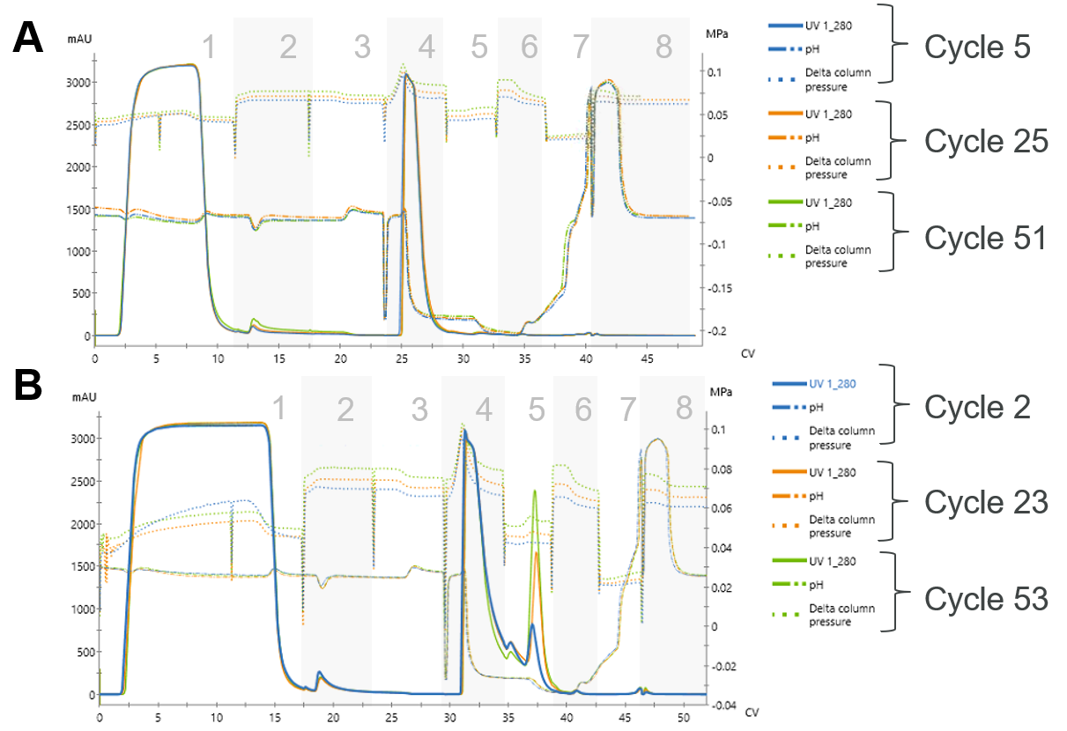
Figure 4. Three chromatogram cycles (indicated) overlaid for mAb 1 (Panel A) and Bs-1 (Panel B) including pressure and pH traces. Chromatogram phases shown are 1) sample load and buffer chase, 2) Wash, 3) Re-equilibration, 4) Elution, 5) Strip 1, 6) Re-equilibration, 7) fast CIP, and 8) Regeneration. Traces from mAb 1 overlap in all phases while traces from Bs-1 in the first strip phase show increased mAb lost on the column. Sanitization conditions were outside manufacturer’s recommendations, both higher in stringency and contact time.

3.3 9.0 mL Membrane Performance and Sanitization

A DBC study for the conditioned medium containing an IgG1, mAb 3, and one hundred purification cycles were run on a prototype 9 mL device (RD61699-3) now commercially available (PROA103). The DBC10% was 33 g/L by Protein A HPLC and a load challenge of 30 g/L was used for the cycling study. After one hundred cycles (Figure 5) the recovery had decreased from 99.8% to 94.5% and the monomer purity remained largely unchanged. The recovery for cycle 30 was determined to be an outlier – Figure S5. This was supported by the overlay of chromatograms for cycle 20, 30, and 40 which suggested a slight underestimation of recovery for cycle 30 – Figure S6.
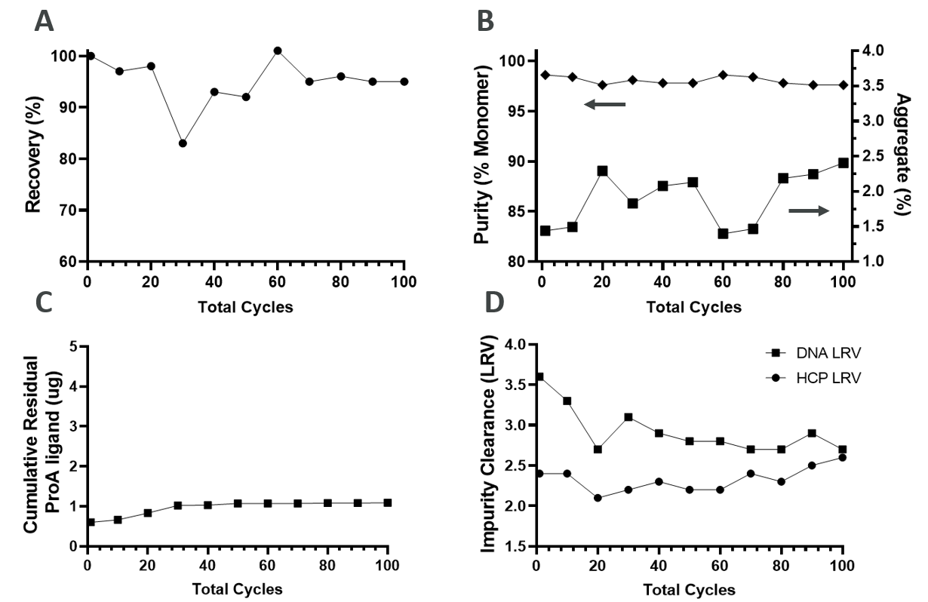
Figure 5. Recovery % (Panel A), HPSEC derived monomer purity % and Aggregate content (Panel B; left and right respectively), cumulative residual protein A ligand (Panel C), Impurity clearance (Panel D; HCP and DNA LRV) for mAb 3 on a 9 mL Gore® Protein A Capture device over 100 purification cycles.
Though the stable product purity for mAb 3 on the 9ml membrane is consistent with mAb 1-4 recorded on the 58 mL membrane data product recovery was maintained around 95% after 100 cycles. Impurity removal was generally conserved over 100 cycles for HCPs while DNA clearance decreased slightly by ~0.5 LRV. Since mAb 3 was not processed under both gentle and harsh sanitization regimes, effects of sanitation cannot be directly attributed to recovery retention over the membrane’s lifetime. We also expect further testing would support gentle sanitization would lead to better retention of product recovery as shown in manufacturer’s data²³. Importantly here, the cumulative residual protein A ligand recorded after 100 cycles was 1.1 µg, nearly two orders of magnitude less than the rigorous sanitization.
Ensuring endotoxin-free purification of therapeutics is critical, especially for the material supply of new therapeutics whose cell-based or animal research studies inform the advancement of medicine development. Although, Cytiva’s HiTrap Fibro PrismA demonstrated stable DBC up to 300 cycles for short alkaline sanitization times (1 min) for 0.5 M and 1 M NaOH supporting low-cost means for contamination mitigation²⁵, endotoxin clearance data was not shown and more conservative sanitation may be needed. The Gore® Protein A capture device is recommended for single use, we show here the stability of eluate purity and impurity clearance over ~50 cycles for four products under harsher sanitization conditions (0.5 N NaOH) than the manufacturer’s recommendations. Overall, recovery is substantially retained over 100 cycles when sanitization is carried out following manufacturer’s recommendations, as demonstrated at the 9 mL scale.

3.4 Membrane Productivity
While productivity is a useful means of comparing membrane performance, computed as mass of product produced per hour per volume of membrane or resin³⁰, practical targets can be set to maximize the number of process steps that can be completed in a working day.
Table 2 reports productivity values based on DBC values, initial run recoveries for mAbs 1-3, Bs-1, and Fc-1 ignoring the long CIP phase and is lower than other reported productivities of 125 g/L/h (loaded at 6 g/L, 6-9 s residence time) ²⁰ and 160.3-206.9 g/L/h (loaded at 1 g/L, 12 s residence time)³⁰ for affinity membrane adsorbers and though for other membranes run in periodic continuous mode, higher productivities were possible³¹. Importantly, since productivity is a function of product titer, capacity, phase duration, and residence time, comparisons between individual membranes should consider those factors. For example, comparing results in Table 2 with those from Grunberg et. al³⁰, the unoptimized method in Table 1 contains more non-load phase volumes, comparable binding capacity, similar but slightly lower titers between 2.3-4.3 mg/mL but with lower residence time. While not tested, a Gore®-recommended, optimized method pairing down phase volumes and residence times for most phases except for loading (supplementary Table S3) was proposed, which would result in increased productivities of 86-158 g/L/h if recoveries achieved in Table 2 were unaffected.
Though reduced membrane adsorber phase volume can decrease buffer consumption, binding capacity and the resulting number of cycles, method optimization, and interestingly, increased buffer use from pump wash steps resulting from washing larger volume pump skids required to accommodate high process flowrates also contribute to overall buffer use ⁹.
Table 2. Productivity for 5 products purified using Gore® Protein A Capture Device (two scales).
Product | mAb 1ª | mAb 2ª | mAb 3^{b} | Bs-1ª | Fc-1ª
Titer (g/L) | 6.3 | 5.3 | 5.9 | 3.1 | 2.5
Load Capacity (mg/mL) | 33.0 | 30.0 | 30.0 | 35.0 | 25.0
Recovery (%) | 91% | 87% | 99% | 78% | 79%
Productivity (g/L/h) | 85 | 73 | 85 | 68 | 50
ª tested on 58mL membrane (ProA 201) using method in Table 1 ^{b} tested on 9mL membrane (ProA 103) using method in Table 1 with modifications described in section 2.3.
To address low-titer loading applications, binding capacity was measured for mAb 4 at transient culture relevant titers in a 9 run central composite style design of experiment. Figure 6 plots the resulting DBC10% values and productivity values for 0.2 – 2.0 mg/mL titer and 20 – 120s residence time (Supplementary Table S4). DBC10% was generally insensitive to titer in this range, though at the slowest flowrate, increasing titer by an order of magnitude marginally increases DBC10% by 4%, if at all, less than trends observed in higher titer studies¹⁶. Future work investigating the dynamic adsorption processes underlying these findings could lead to new insights to support process understanding and scaling for further adoption.
Considering residence time, DBC10% was increased by up to 37% by loading 6 times more slowly; however, despite this gain in capacity, overall productivity drops of 81%, 73%, and 38% for 0.2, 1.0, and 2.0 mg/mL titer respectively at 120s compared to 20s residence time. Taken together, for low titer applications, higher productivity can be achieved with low residence times, outweighing any small gains in capacity from loading the membrane more slowly.
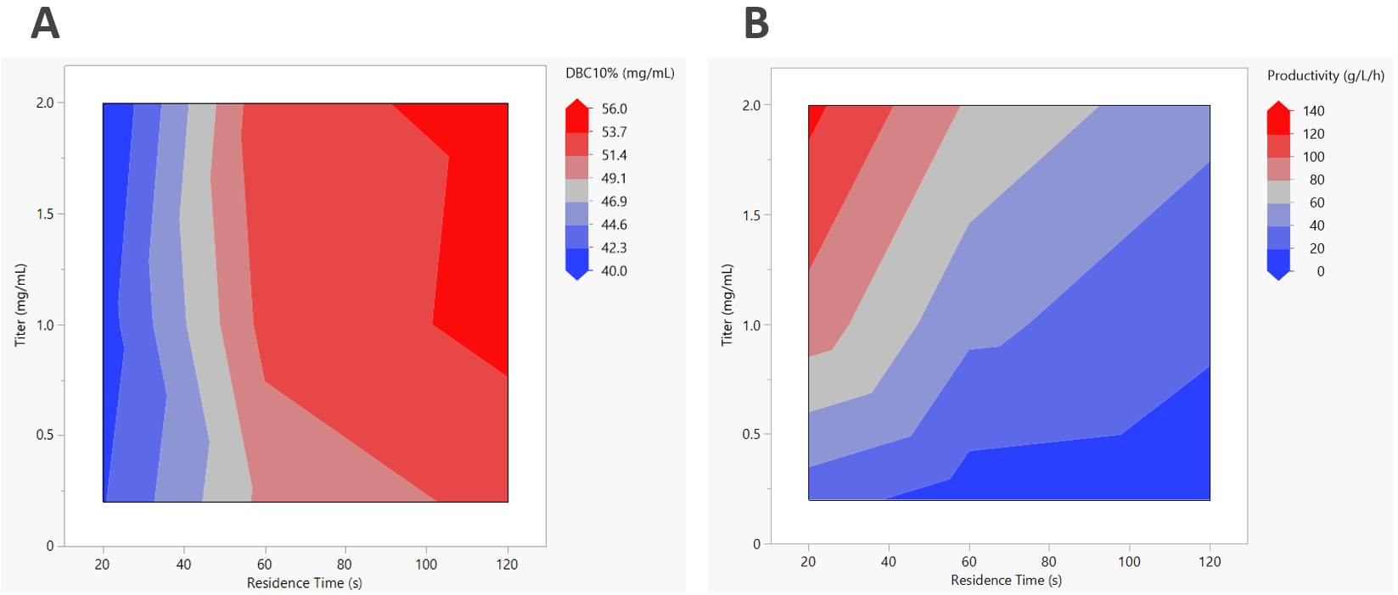
Figure 6. Contour plots of DBC10% (mg/mL; Panel A) and Productivity (g/L/h; Panel B) plotted against both loading residence time (s) and load titer (mg/mL).
More practically, to purify a 50 L, 0.2 mg/mL titer clarified harvest at 20 s residence time and maximum capacity of 33.7 mg/mL (Table S4; applying a safety factor of 0.8) on a 58 mL unit, it would take 6 equal cycles at 28.7mg/ml capacity, with 48 min of loading per cycle (66 minutes total per cycle), completing in about 6.6 h with the conservative, Table 1 method, resulting in a productivity of 27.4 g/L/h. In contrast, leveraging the larger 393 mL MabSelect™Sure™ column (20 cm bed height, 5 cm diameter, run according to method in Table S3) to hasten purification in a single cycle, the estimated elapsed time would be 10.4 h, resulting in a productivity of 2.2 g/L/h. The significance of this short runtime and over 10 × productivity gain using membrane chromatography is that with the remaining time, additional steps can be queued to run overnight or completed in the same 8 hour working day resulting in two steps completed in a day rather than only one with packed bed chromatography.

4.0 Conclusions

This work evaluated the performance of the Gore® capture device with Protein A at 58 mL pilot scale, 9 mL scale for multiple products over 50 or 100 cycles per membrane respectively, and the effect of titer and loading residence time on DBC at the 1 mL scale. Product recovery, purity, impurity (HCP, DNA) clearance, and leached protein A were measured. DBC10% and productivity were also computed to emphasize the benefit of low residence times for low-titer feeds relevant to transient culture.
Overall, while following manufacturer’s recommendations for sanitization and safety factor, recovery and purity can be substantially retained over 100 cycles of use as tested at the 9 mL scale. Under rigorous sanitization conditions as those normally applied to packed bed columns adapted to NaOH resistance, for feeds applied to the 58 mL membrane, high HCP and DNA clearance is retained along with purity over at least 50 cycles although a product specific drop in recovery may be observed related to Protein-A leaching resulting from the rigorous sanitization conditions. The causes of such product specific behavior could be investigated in future work leading to new insights into impurity, product, and ligand interactions.
High flowrates are recommended for higher productivity and outweigh relatively smaller gains in capacity from loading membranes more slowly. For this work focused on high-volume, low-titer purification applications such as material generation for novel research products generated in transient CHO cultures – at scales where productivity gains outweigh buffer consumption concerns – membrane chromatography is preferred to reduce load times, thereby increasing process intensity of affinity chromatography.
Looking forward, for low-titers in perfusion bioreactors, characteristic of the first days in a continuous manufacturing campaign, the range of loading flowrates offered with high performance and 100+ cycle lifetime may provide an added level of beneficial processing flexibility. Still, at production scale, buffer consumption and the resulting cost of goods manufactured should be considered when switching from packed bed to membrane based chromatography.

Acknowledgements
The authors are grateful for the contributions to sample testing from AstraZeneca analytical groups who ran product titer assays, residuals testing for HCP, genomic DNA, and leached Protein A ligand as well as for contributing to the methods sections describing their use. The authors also acknowledge W.L Gore® and Associates for providing the appropriate sample membranes at 58 mL and 9 mL scales for testing. There is no conflict of interest.

Works Cited
1. Li H, Er Saw P, Song E. Challenges and strategies for next-generation bispecific antibody-based antitumor therapeutics. Cell Mol Immunol. May 2020;17(5):451-461. doi:10.1038/s41423-020-0417-8
2. Czajkowsky DM, Hu J, Shao Z, Pleass RJ. Fc-fusion proteins: new developments and future perspectives. EMBO Mol Med. Oct 2012;4(10):1015-28. doi:10.1002/emmm.201201379
3. Shukla AA, Wolfe LS, Mostafa SS, Norman C. Evolving trends in mAb production processes. Bioeng Transl Med. Mar 2017;2(1):58-69. doi:10.1002/btm2.10061
4. Gutierrez-Granados S, Cervera L, Kamen AA, Godia F. Advancements in mammalian cell transient gene expression (TGE) technology for accelerated production of biologics. Crit Rev Biotechnol. Sep 2018;38(6):918-940. doi:10.1080/07388551.2017.1419459
5. Ramos I, Sharda N, Villafana R, et al. Fully integrated downstream process to enable next-generation manufacturing. Biotechnol Bioeng. Jul 2023;120(7):1869-1881. doi:10.1002/bit.28384
6. Schwarz H, Gomis-Fons J, Isaksson M, et al. Integrated continuous biomanufacturing on pilot scale for acid-sensitive monoclonal antibodies. Biotechnol Bioeng. Aug 2022;119(8):2152-2166. doi:10.1002/bit.28120
7. Lei Y, Shen Y, Zuo C, et al. Emerging affinity ligands and support materials for the enrichment of monoclonal antibodies. TrAC Trends in Analytical Chemistry. 2022;157doi:10.1016/j.trac.2022.116744
8. Liu Z, Wickramasinghe SR, Qian X. Membrane chromatography for protein purifications from ligand design to functionalization. Separation Science and Technology. 2016;52(2):299-319. doi:10.1080/01496395.2016.1223133
9. Qu Y, Bekard I, Hunt B, et al. The Transition from Resin Chromatography to Membrane Adsorbers for Protein Separations at Industrial Scale. Separation & Purification Reviews. 2023:1-21. doi:10.1080/15422119.2023.2226128
10. Serdakowski London A, Kerins B Fau - Tschantz WR, Tschantz Wr Fau - Eisfeld J, Eisfeld J Fau - Mackay K, Mackay K. Endotoxin removal and prevention for pre-clinical biologics production. (1860-7314 (Electronic))
11. Valente JFA, Queiroz JA, Sousa F. Dilemma on plasmid DNA purification: binding capacity vs selectivity. J Chromatogr A. Jan 25 2021;1637:461848. doi:10.1016/j.chroma.2020.461848
12. Nadar S, Shooter G, Somasundaram B, Shave E, Baker K, Lua LHL. Intensified Downstream Processing of Monoclonal Antibodies Using Membrane Technology. Biotechnol J. Mar 2021;16(3):e2000309. doi:10.1002/biot.202000309
13. Cytiva. Cytiva HiTrap Fibro PrismA units Hiscreen fibro prismA units - Affinity Chromatography. 2021(CY7145-19Jan21-DF). https://cdn.cytivalifesciences.com/api/public/content/digi-33339-pdf
14. Bramer C, Tunnermann L, Gonzalez Salcedo A, et al. Membrane Adsorber for the Fast Purification of a Monoclonal Antibody Using Protein A Chromatography. Membranes (Basel). Nov 27 2019;9(12)doi:10.3390/membranes9120159
15. Ricarda A. Busse* MG, Kim B. Kuchemueller, Katrin Toeppner, Patrick Adametz, Volkmar Thom. Sartobind® Rapid A: Comparable High Product Quality as Protein A Resins at High Productivity. Application Note. Satrorius. 2022-June-28 2022;
16. Osuofa J, Husson SM. Comparative Evaluation of Commercial Protein A Membranes for the Rapid Purification of Antibodies. Membranes (Basel). May 12 2023;13(5)doi:10.3390/membranes13050511
17. W.L. Gore & Associates I. Increase Productivity With High Binding Capacity And Short Residence Time For Antibody Purification Gore Protein Capture Device with Protein A, for clinical and routine bioprocessing - For Rapid Purification of Antibodies. Application Note. PB10133-R4-DH5-US-MAR23. 2023
18. McManaway Michael C, inventor; GORE & ASSOCIATES, assignee. Affinity chromatography devices. US patent US 10974170 B2. patent application US 201916689677 A. 2021/04/13 2021.
19. Purologics. Purexa PrA for Antibody Purification Updated 05.23. Accessed 2023-Sep-22, 2023. https://static1.squarespace.com/static/64251de3583fb50462a201b1/t/642951f273b4e20365c386b0/1680429557509/Purilogics+Purexa+PrA+datasheet.pdf
20. Benoit Mothes JP, Kathrin Schroeder-Tittmann, and Louis Villain. Accelerated, Seamless Antibody Purification - Process Intensification with Continuous Disposable Technology BioProcess Technical. 2016;14(5):34-58.
21. Ramos-de-la-Pena AM, Gonzalez-Valdez J, Aguilar O. Protein A chromatography: Challenges and progress in the purification of monoclonal antibodies. J Sep Sci. May 2019;42(9):1816-1827. doi:10.1002/jssc.201800963
22. W.L. Gore & Associates I. High Binding Capacity and Short Residence Time for the Rapid Purification of mAbs. Gore Protein Capture Device with Protein A - For Drug Discovery Applications. Technical DataSheet. PB6575-REV6-US-NOV22. 2022. November 2022. Accessed 30 Jan 2024. https://www.gore.com/system/files/2023-05/GORE_PCD_DD_DataSheet_US_NOV22.pdf
23. W.L. Gore & Associates I. High Binding Capacity and Short Residence Time for High-Productivity Antibody Purification GORE Protein Capture Device with Protein A, 90mL - For Process Development, Pre-clinical, and Early Clinical Applications. GORE_ProteinCaptureDevice_9mL_Datasheet_JAN20_EN_e.pdf. W.L. Gore & Associates, Inc.; 2020:1-2. 2020. Accessed 2023/02/24. https://www.gore.com/system/files/2020-04/GORE_ProteinCaptureDevice_9mL_Datasheet_JAN20_EN_e.pdf
24. McManaway M, inventor; W.L. Gore & Associates, Inc. , assignee. Affinity Chromatography Devices. US patent application US10974170 B2. 2021.
25. Cytiva. HiTrap Fibro PrismA units, HiScreen Fibro PrismA units - Affinity Chromatography. 2021;CY7145-19Jan21-DF.
26. David Westman AF, Gustav Rodrigo, Thomas Björkman, and Jelena Vasic. A next-generation Protein A resin for improved productivity and bioburden control. Application Note. Cytiva. 2017;CY15160-12Jul20-PT.
27. Ghose S, Allen M, Hubbard B, Brooks C, Cramer SM. Antibody variable region interactions with Protein A: implications for the development of generic purification processes. Biotechnol Bioeng. Dec 20 2005;92(6):665-73. doi:10.1002/bit.20729
28. Ghose S, Hubbard B, Cramer SM. Binding capacity differences for antibodies and Fc-fusion proteins on protein A chromatographic materials. Biotechnol Bioeng. Mar 1 2007;96(4):768-79. doi:10.1002/bit.21044
29. da Silva GFL, Plewka J, Tscheliessnig R, Lichtenegger H, Jungbauer A, Dias-Cabral ACM. Antibody Binding Heterogeneity of Protein A Resins. Biotechnol J. Aug 2019;14(8):e1800632. doi:10.1002/biot.201800632
30. Grunberg M, Kuchemuller KB, Toppner K, Busse RA. Scalable, Robust and Highly Productive Novel Convecdiff Membrane Platform for mAb Capture. Membranes (Basel). Jun 30 2022;12(7)doi:10.3390/membranes12070677
31. Davis RR, Suber F, Heller I, Yang B, Martinez J. Improving mAb capture productivity on batch and continuous downstream processing using nanofiber PrismA adsorbents. J Biotechnol. Aug 10 2021;336:50-55. doi:10.1016/j.jbiotec.2021.06.004

